1. 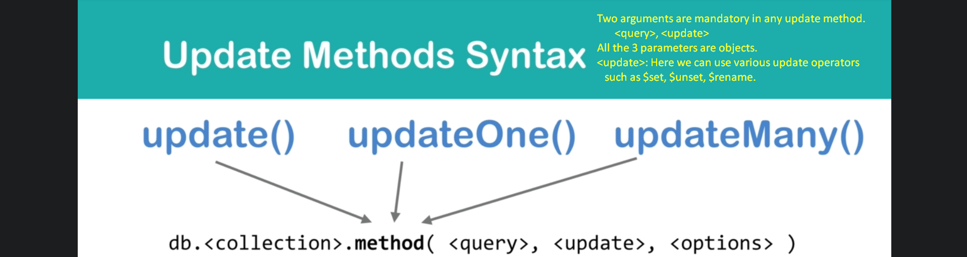
   1. Two arguments are mandatory in any update method. <query>, <update>
   2. All the 3 parameters are objects.
   3. <update>: Here we can use various update operators.